**Vasudev R**

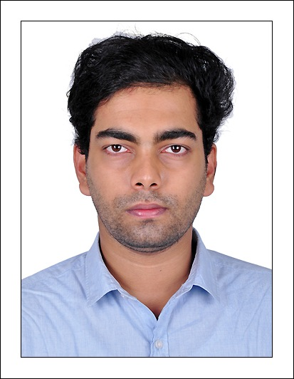

**Phone num: +91 6282563293**

**Email id:** [**vdrss3@gmail.com**](mailto:vdrss3@gmail.com)

**LinkedIn:** [**https://www.linkedin.com/in/vasudev-rv-430538133**](https://www.linkedin.com/in/vasudev-rv-430538133)

**Address: Saketham House,**

**Puthiyakavu, Kaniyavalli Road ,Tripunithura**

**Ernakulam, Kerala, Pin : 682301**

**EXPERIENCE**

**Research Intern -** Continental Automotive Components (India) Pvt. Ltd

Bangalore, Karnataka

**SKILLS**

ALGORITHMS

DATA STRUCTURES

PYTHON, C++, C, JAVASCRIPT

MONGODB, MySQL

HTML, BOOTSTRAP

SEPTEMBER 2022- JULY 2023 (10 Months)

Skills**: Python, C++ , Simulation, 2D image processing, 3D modelling, Carmaker**

**Software Developer Trainee** – Toobler Technologies Pvt Ltd

Infopark Kochi, Kerala

FEBRUARY 2021- AUGUST 2021 (6 Months)

Skills : React JS, Node JS, Javascript, MongoDB, MySQL

**EDUCATION**

**STRENGTHS**

Developing

Quick Learner

Patience

Ready to take initiative

Communication

Likes to work with new Technologies

Self Motivated

Leader as well as Team player

**MTech Computer Science and Engineering-** AMRITA SCHOOL OF ENGINEERING

AMRITA VISHWA VIDHYAPEETHAM

(2021 – 2023) BATCH

CGPA- 8.2

**BTech Computer Science and Engineering** – Vishwajyothi College of Engineering

Dr APJ ABDUL KALAM TECHNOLOGICAL UNIVERSITY

(2016 – 2020) BATCH

CGPA- 6.47

**HIGHER SECONDARY EDUCATION** – NSS HIGHER SECONDARY SCHOOL VARAPETTY

Government of KERALA

CGPA – 9.4

**PROJECTS**

**HOBBIES**

Learning new Algorithms

Research

Playing Football

Analyzing Football Matches

Marathon

Fitness

**PHOTOREALISTIC SCENARIO RECONSTRUCTION FOR AUTOMATED DRIVING**

**CONTINETAL AUTOMOTIVE PVT LTD (**During Internship)

JUNE - 2023

**MULTIFACTOR AUTHENTICATION WITH ID CARD CREDENTIALS FOR SECURED TRANSCATIONS**

**AMRITA VISHWA VIDYAPEETHAM**

JUNE - 2023

**TELEPHONE DIRECTORY SYSTEM USING TRIE DATA STRUCTURE**

**AMRITA VISHWA VIDYAPEETHAM**

Using Python Programming Language in Google Colab also including a comparative study with

Doubly Linked List and DataFrame

FEBRUARY- 2022

**PROPOSED SYSTEM - IMPROVING SECURITY FEATURES OF ZOOM**

Based on various basic tools of cyber security , proposed a system that can improve security features

of Zoom during its initial stages.

FEBRUARY- 2022

**EMOTION RECOGNITION USING CNN**

Face images are collected and categorized, to check whether the person is happy or not

FEBRUARY- 2022

SUMMARY An enthusiastic fresher with highly motivated and leadership skills having bachelors of engineering degree in Computer Science and Engineering. Expert in implementation of each step of project. Eager to learn new technologies and methodologies. Always willing to innovate the new things which can improve the existing technology. To work for the organization which provides me the opportunity to improve my skills and knowledge to growth along with the organization’s objectives